Dear Community Partner:
On June 13, 2025, Veracity Helping Hands Foundation will be holding its 3rd annual golf tournament at Rebel Creek Golf Club in Petersburg, Ontario in support of Women’s Crisis Services of Waterloo Region (WCSWR). Since 2023, the Veracity Helping Hands Foundation has worked alongside local charities and special interest groups throughout the province of Ontario on a wide array of public and private initiatives. The Foundations’ main objective is to support and promote the programs of our benefactors in order to not only improve the quality of life of those it supports, but also for the general betterment of the communities in which we reside. It is through a dedicated team of professionals and volunteers and the generous support of local businesses and private individuals that we are able to undertake our mission to improve the social fabric of the communities in which we live, work and play. We are a not-for-profit organization, and all net proceeds of our events go directly to the charities and community groups we work with on a regular basis.
WCSWR empowers and supports women and children to move beyond violence by providing safe shelter, education and outreach services. WCSWR operates two emergency shelters for women and children experiencing domestic violence: Anselma House in Kitchener and Haven House in Cambridge. In addition to providing safe shelter, WCSWR offers a free, confidential, outreach program for women who are experiencing domestic violence but do not require emergency shelter. The program is flexible, accessible and has no wait list. In shelter support and services include:
- 24/7 support, this includes legal needs, housing, parenting, or transitioning towards independence;
- ongoing support is provided both one-on-one and through groups;
- education on domestic violence and violence against women;
- food and nutrition programs;
- child and youth programming;
- employment search; and,
- safety planning.
While additional outreach services include:
- safety planning;
- assistance/advocacy with housing providers and/or Ontario Works;
- support around the legal process including assistance in connecting with a lawyer and/or legal aid;
- completion of 2 hour free legal aid forms;
- referrals to lawyers;
- referrals and advocacy to other community agencies as needed;
- interpreters can be arranged;
- 1 on 1 meetings;
- employment search support; and, education about violence against women.
Our charity is looking for businesses and individuals who may be interested in supporting our event this year in order to assist WCSWR in their delivery of the foregoing programs in their stand against domestic violence against women. There are many ways you can support our initiative: sponsorship, registration to the golf tournament, donations in kind (silent auction items/ prizes/monetary), volunteering, etc. If you would be interested in sponsoring out event, the details of each sponsorship level can be found below:
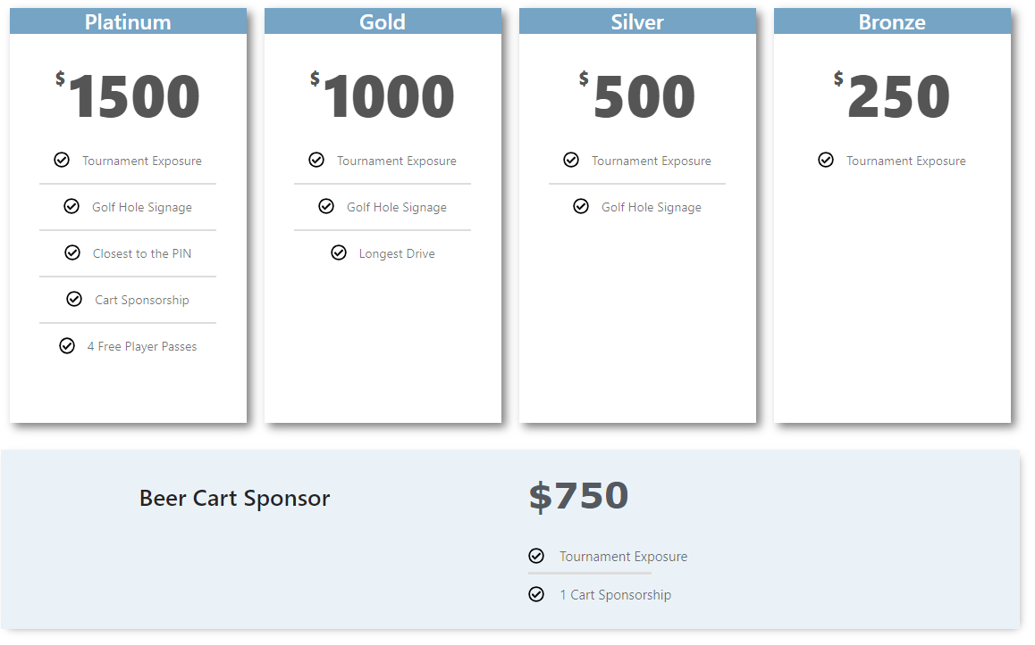
Should you require any further information on sponsorship opportunities or have any other questions regarding our charity or the partners we support, please feel free to reach out to the undersigned at any time.
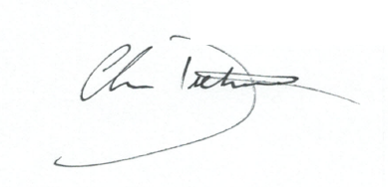
We greatly appreciate your interest and look forward to connecting with you soon.
Kind regards,

Chris Dietrich, AACI, SR/WA, Tournament Coordinator
Veracity Real Estate Solutions, PO Box 1051, Ayr, ON N0B1E0
Cell: 519-504-1234 Email: wcswr@veracityres.com

